**Experiment No : 4(a)**

**Name : Mohammad Sohail Shaikh A56**

**Code: Write a Python program to print the numbers of a specified list after removing even numbers from it.**

def remove_even_numbers(numbers):

"""

Removes even numbers from a list.

:param numbers: List of integers

:return: List with only odd numbers

"""

return [num for num in numbers if num % 2 != 0] # Keep only odd numbers

# Example list

num_list = [1, 2, 3, 4, 5, 6, 7, 8, 9, 10]

# Remove even numbers

filtered_list = remove_even_numbers(num_list)

# Print the result

print("List after removing even numbers:", filtered_list)

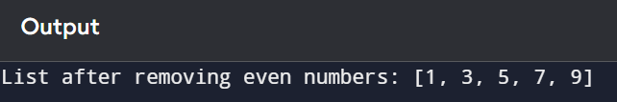

**4(b)**

**Code: write a python program to check whether an element exist within a tuple.**

def check_element_in_tuple(tup, element):

"""

Checks if an element is present in the tuple.

:param tup: Tuple of elements

:param element: Element to check

:return: True if element is found, otherwise False

"""

return element in tup # Returns True if element is found, otherwise False

# Example tuple

my_tuple = (10, 20, 30, 40, 50)

# Get user input

element = int(input("Enter the element to search: "))

# Check if the element is in the tuple

if check_element_in_tuple(my_tuple, element):

print(f"{element} is present in the tuple.")

else:

print(f"{element} is NOT present in the tuple.")

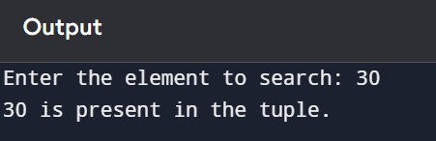

**4(c)**

**Code: write a python program to iterate over dictionaries using for loops.**

# Example dictionary

student_info = {

"Name": "John",

"Age": 20,

"Course": "Computer Science",

"Grade": "A"

}

# Iterating through the dictionary using a for loop

print("Dictionary Keys and Values:")

for key, value in student_info.items():

print(f"{key}: {value}")

